In java the primitive data types variables lives in the stack

Only the objects lives in the heap

But

We can also make the primitive data values like integers, char, as objects by wrapper classes

Wrapper classes wrap the primitive data types inside them so the formed objects will live in the heap

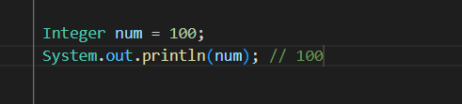

here num is reference variable living in stack and pointing to the object living in heap

Since num is an object we have many methods provided by java

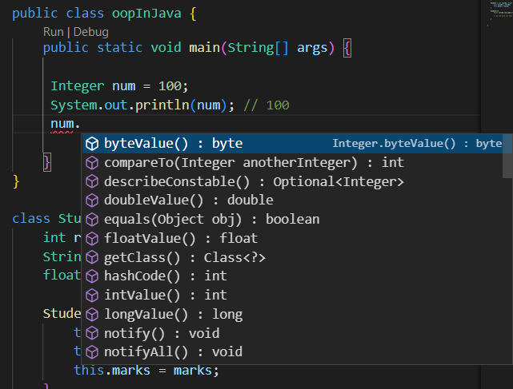

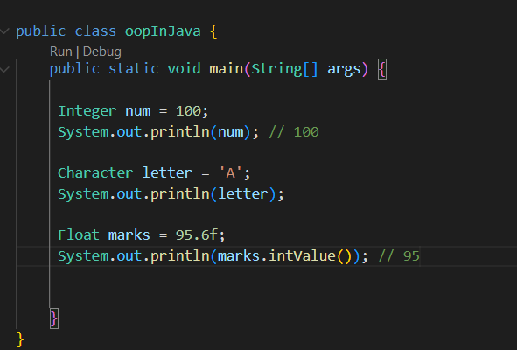

These are the objects made from the wrapper classes

these objects has many predefined methods available to them which are really useful

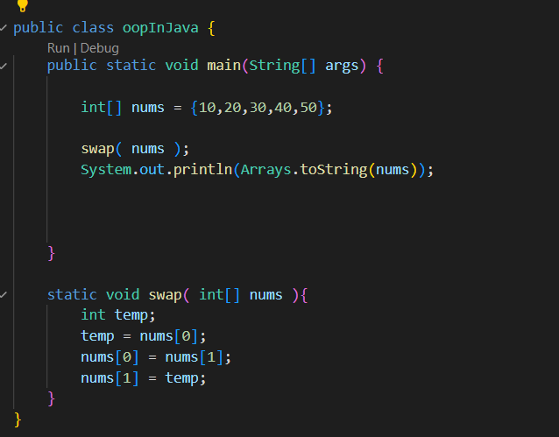

here nums[0] and nums[1] are the references and the variable temp is assigned to the nums[0]

becoz they were references and were pointing to the actual values we were able to swap like this

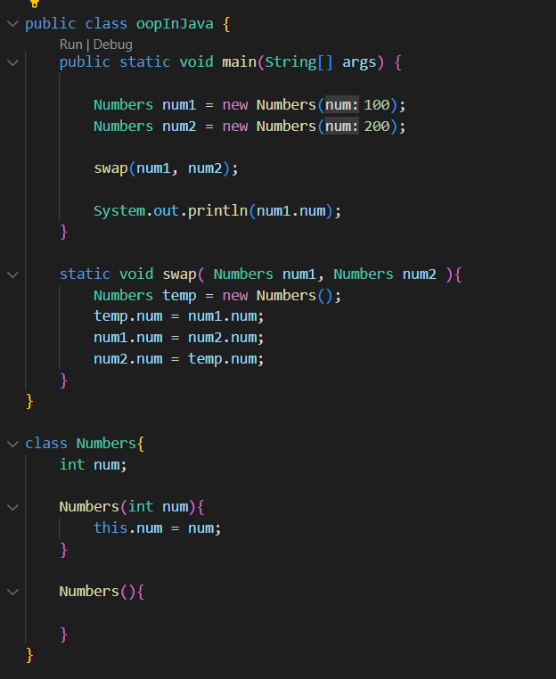

Here also swap works since the references were passed to the swap function and we know all the reference variable points to the same object

